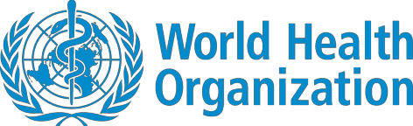

Coronavirus disease (COVID-19)
Situation Report – 106
Data as received by WHO from national authorities by 10:00 CEST, 5 May 2020
This report has been reformatted to improve accessibility for persons with visual impairment.

Highlights
Every year on May 5 we celebrate Hand Hygiene Day to mobilize people around the world to increase adherence to hand hygiene practices inhealthcare facilities. In his media briefing,the Director-General remindedus that ‘around the world, fewer thantwo-thirds of healthcare facilitiesare equippedwith hand hygiene stations,and 3 billionpeople lacksoap and water at home’.Dr PoonamKhetrapal Singh, WHO Regional Director for South-EastAsia, saidthat ‘Effective infection prevention and control measures, including hand hygiene, are crucial to ensuring healthfacilitiesdo not become hubs of COVID-19 transmission’.

A WHO COVID-19 mission has arrived in Tajikistan to supportthe country’s response to the pandemic.

Today also marksthe International Day of the Midwife. Midwivesprovide life-saving servicesto pregnant women,ensuring healthy outcomesfor women and their babies. As the Director-General said in his media briefing, ‘They’re risking their livesto give life to others.’WHO Regional Office for Europe has released a newsarticle of the experiences of a midwife in Italy.
Yesterday leaders from 40 countries around the worldcame together to supportthe Accessto COVID- 19 Tools (ACT) Accelerator, a WHO initiative to support the development,productionand equitable distributionof vaccines, diagnostics andtherapeutics against COVID-19.Some €7.4 billion were pledged, in what the Director-General described as a ‘powerful and inspiring demonstration of global solidarity’.

Situation in numbers (by WHO Region)
Total (new cases in last 24 hours)

Globally | 3 517 345 cases (81 454) | 243 401 deaths (3797)
Africa | 32 570 cases (2036) | 1112 deaths (27)
Americas  Eastern Mediterranean | 1 477 447 cases (43 691)  213 376 cases (7077) | 79 590 deaths (1763)  8115 deaths (144)
Europe  South-East Asia | 1 566 684 cases (22 539)  72 688 cases (5015) | 145 602 deaths (1615)  2682 deaths (219)
Western Pacific | 153 868 cases (1096) | 6287 deaths (29)

Subject in Focus: Operations Support and Logistics update
UN-led purchasing consortiumprocures diagnostic tests for delivery to 135 countries

Unprecedented globaldemand for PersonalProtective Equipment (PPE), ventilators and othercritical items for the COVID-19 response has resulted in acute supply shortages. WHO is working across several different sectors to enable countries with the most limited means to access markets for vitalmedical supplies to tackle the COVID-19 pandemic.

WHO – together with otherUN agencies, NGOs and donor partners – are negotiating collectively with manufacturers through a pooled procurement process, to address global market shortages in the three categories of vital supplies essential for the COVID-19 response: PPE; diagnostics; and biomedical equipment.

With support from the Solidarity Response Fund, the diagnostics consortiumhas secured 4 million manual Polymerase Chain Reaction (PCR)tests for $49 million, and initiated purchase orders for allocation and distribution to 135 countries for the month of May. Theseinitial purchases will serveas a catalyst for securing supplies for additional procurement, as payments from countries receiving these deliveries will provide additional funding for procuring more supplies and equipment for allocation and delivery in the coming months.

WHO is engaged in discussions with suppliers to explore furtherchannels of cooperation for sourcing pooled procurement of PPE, testing supplies and biomedical equipment. Through a purchasing consortiumfor PPE, contracts have been secured from Chinese and Malaysian manufacturers for substantial volumes of masks, gloves and other critical supplies to protect frontlinehealthcareworkers. WHO is currently in the process of placing purchase orders for these supplies, while the consortium continues efforts to secure additional quantities of PPE.

WHO continues to strongly advocate for the urgent need to increase production of these life-saving supplies to strengthen response capacity of Member States confronting the COVID-19 pandemic.

COVID-19 Supply Portal Launch

WHO has launched a new COVID-19 Supply Portal.

The COVID-19 Supply Portal is a purpose-built tool to facilitateand consolidatesubmission of supply requests from national authorities and all implementing partners supporting COVID-19 National Action Plans. Those requests will then be matched against purchasing agencies of the Consortia that can executethe order and process it, utilizing their existing ordering systems. A catalogue of items that can be requested is available online and is broadly divided into three categories: personal protectiveequipment, diagnostics, and clinical management. The Portal is accessed via the COVID-19Partners Platform, which is accessed here, and provides further information including a video and guide to requesting and receiving supplies and frequently asked questions.

Guidance on its roll-out and use has been provided to the UN Development Coordination Office, WHO Regional Directors, UN agencies and other key actors. WHO is preparing a circularto introducethe Portal to Member States and national authorities.

https://www.who.int/emergencies/diseases/novel-coronavirus-2019/strategies-plans-and-operations/
Surveillance
Figure 1. Number of confirmed COVID-19 casesreportedin the last sevendays by country, territory or area, 29 April to 5 May**

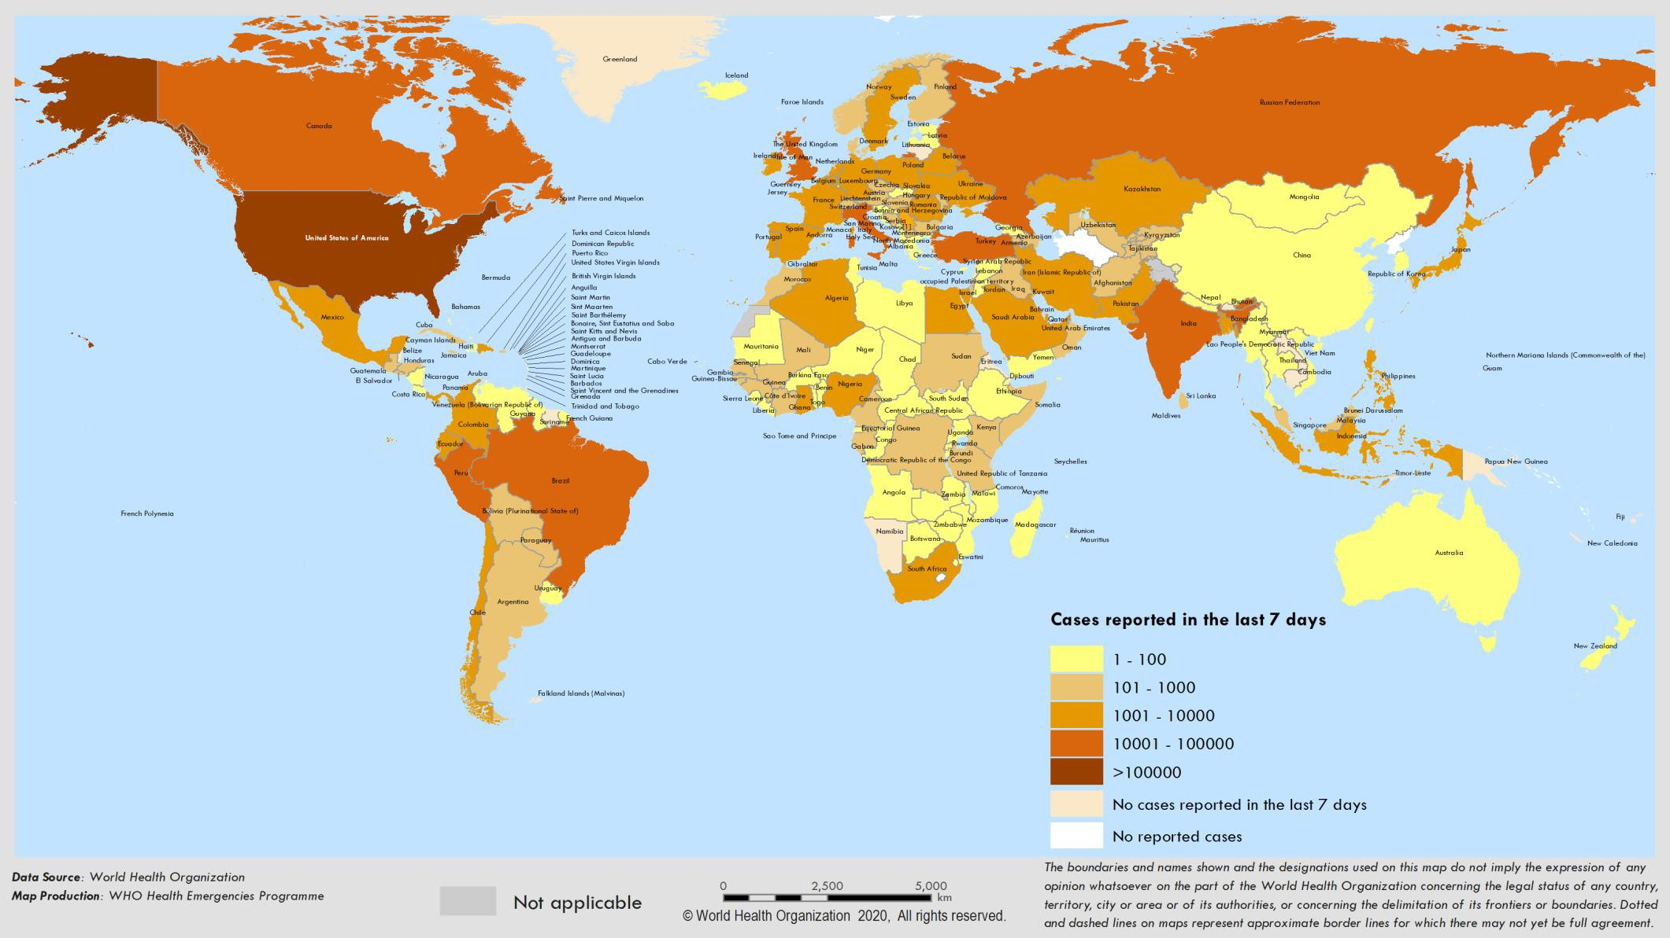

90000
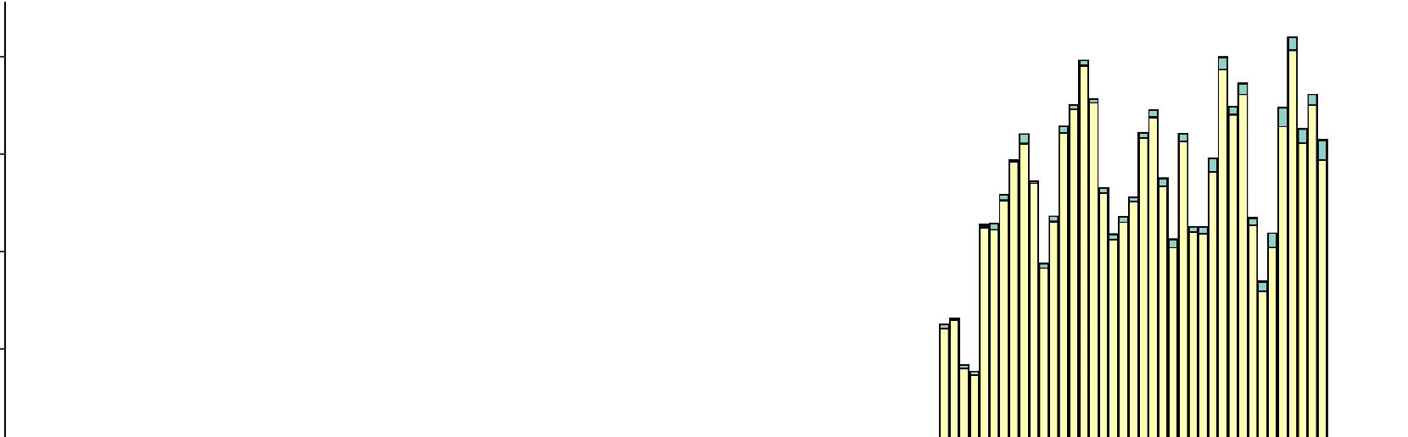

80000

70000

20000
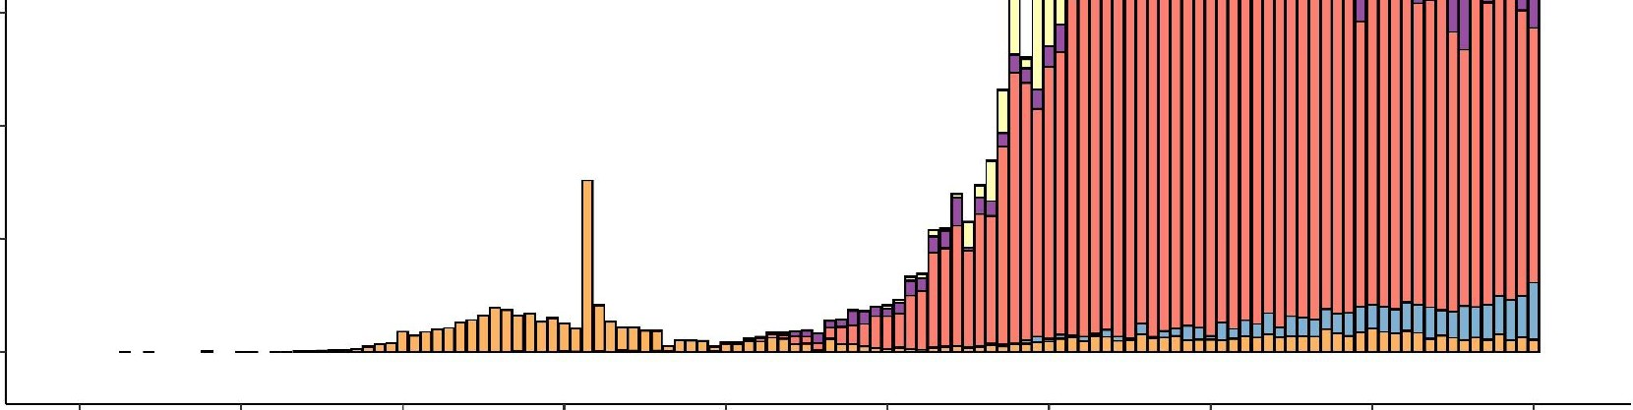

10000

Date of report
0
 | 30 Dec | 13 Jan | 27Jan | 10 Feb | 24 Feb | 09Mar | 23 Mar | 06 Apr | 20Apr | 04May
 | 2019 | 2020 | 2020 | 2020 | 2020 | 2020 | 2020 | 2020 | 2020 | 2020

Reporting Country/ Territory/Area | Total confirmed cases | Total confirmed new cases | Total deaths | Total new deaths | Transmission classificationi | Days since last reported case
Africa

South Africa | 7220 | 437 | 138 | 7 | Community transmission | 0
Algeria | 4648 | 174 | 465 | 2 | Community transmission | 0
Nigeria | 2802 | 414 | 93 | 8 | Community transmission | 0
Ghana | 2719 | 550 | 18 | 0 | Clusters of cases | 0
Cameroon | 2077 | 0 | 64 | 0 | Clusters of cases | 2
Guinea | 1710 | 60 | 9 | 2 | Community transmission | 0
Côte d’Ivoire | 1432 | 34 | 17 | 0 | Clusters of cases | 0
Senegal | 1271 | 0 | 10 | 1 | Clusters of cases | 1
Niger | 755 | 5 | 37 | 1 | Clusters of cases | 0
Democratic Republic of the Congo | 682 | 0 | 34 | 0 | Clusters of cases | 1
Burkina Faso | 672 | 10 | 46 | 1 | Community transmission | 0
Mali | 580 | 17 | 29 | 2 | Clusters of cases | 0
Kenya | 490 | 24 | 24 | 0 | Clusters of cases | 0
United Republic of Tanzania | 480 | 0 | 18 | 0 | Clusters of cases | 5
Gabon | 367 | 32 | 6 | 1 | Clusters of cases | 0
Mauritius | 332 | 0 | 10 | 0 | Community transmission | 8
Equatorial Guinea | 315 | 0 | 2 | 0 | Clusters of cases | 6
Guinea-Bissau | 292 | 0 | 2 | 0 | Sporadic cases | 1
Rwanda | 261 | 2 | 0 | 0 | Clusters of cases | 0
Congo | 236 | 7 | 10 | 0 | Clusters of cases | 0
Sierra Leone | 178 | 21 | 9 | 1 | Clusters of cases | 0

Reporting Country/ Territory/Area | Total confirmed cases | Total confirmed new cases | Total deaths | Total new deaths | Transmission classificationi | Days since last reported case

Liberia | 166 | 8 | 18 | 0 | Clusters of cases | 0
Cabo Verde | 165 | 0 | 2 | 0 | Sporadic cases | 1
São Tomé and Príncipe | 161 | 138 | 3 | 0 | Sporadic cases | 0
Madagascar | 158 | 7 | 0 | 0 | Clusters of cases | 0
Ethiopia | 140 | 5 | 3 | 0 | Clusters of cases | 0
Zambia | 137 | 13 | 3 | 0 | Sporadic cases | 0
Togo | 126 | 2 | 9 | 0 | Clusters of cases | 0
Chad | 117 | 0 | 10 | 0 | Sporadic cases | 2
Eswatini | 116 | 4 | 1 | 0 | Sporadic cases | 0
Benin | 96 | 6 | 2 | 0 | Sporadic cases | 0
Central African Republic | 94 | 22 | 0 | 0 | Sporadic cases | 0
Uganda | 89 | 1 | 0 | 0 | Sporadic cases | 0
Mozambique | 80 | 0 | 0 | 0 | Sporadic cases | 1
South Sudan | 49 | 3 | 0 | 0 | Sporadic cases | 0
Malawi | 41 | 2 | 3 | 0 | Sporadic cases | 0
Eritrea | 39 | 0 | 0 | 0 | Sporadic cases | 16
Angola | 35 | 0 | 2 | 0 | Sporadic cases | 2
Zimbabwe | 34 | 0 | 4 | 0 | Sporadic cases | 3
Botswana | 23 | 0 | 1 | 0 | Sporadic cases | 6
Burundi | 19 | 0 | 1 | 0 | Sporadic cases | 2
Gambia | 17 | 0 | 1 | 0 | Sporadic cases | 2
Namibia | 16 | 0 | 0 | 0 | Sporadic cases | 29
Seychelles | 11 | 0 | 0 | 0 | Sporadic cases | 28

Reporting Country/ Territory/Area | Total confirmed cases | Total confirmed new cases | Total deaths | Total new deaths | Transmission classificationi | Days since last reported case

Mauritania | 8 | 0 | 1 | 0 | Sporadic cases | 4
Comoros | 4 | 1 | 1 | 1 | Pending | 0
Territoriesii
Mayotte | 686 | 36 | 6 | 0 | Clusters of cases | 0
Réunion | 424 | 1 | 0 | 0 | Clusters of cases | 0
Americas
United States of America | 1154985 | 29266 | 61906 | 1196 | Community transmission | 0
Brazil | 101147 | 4588 | 7025 | 275 | Community transmission | 0
Canada | 59844 | 479 | 3766 | 85 | Community transmission | 0
Peru | 45928 | 3394 | 1286 | 86 | Community transmission | 0
Ecuador | 31881 | 2343 | 1569 | 5 | Community transmission | 0
Mexico | 23471 | 1383 | 2154 | 93 | Community transmission | 0
Chile | 20643 | 980 | 270 | 10 | Community transmission | 0
Dominican Republic | 8235 | 281 | 346 | 13 | Community transmission | 0
Colombia | 7668 | 383 | 340 | 16 | Community transmission | 0
Panama | 7197 | 107 | 200 | 3 | Community transmission | 0
Argentina | 4799 | 118 | 250 | 9 | Community transmission | 0
Cuba | 1668 | 19 | 69 | 2 | Clusters of cases | 0
Bolivia (Plurinational State of) | 1594 | 124 | 76 | 5 | Clusters of cases | 0
Honduras | 1055 | 45 | 82 | 6 | Clusters of cases | 0
Costa Rica | 739 | 6 | 6 | 0 | Clusters of cases | 0
Guatemala | 703 | 15 | 17 | -2 | Clusters of cases | 0
Uruguay | 655 | 3 | 17 | 0 | Clusters of cases | 0
El Salvador | 555 | 65 | 12 | 1 | Clusters of cases | 0

Reporting Country/ Territory/Area | Total confirmed cases | Total confirmed new cases | Total deaths | Total new deaths | Transmission classificationi | Days since last reported case

Jamaica | 469 | 6 | 9 | 1 | Clusters of cases | 0
Paraguay | 396 | 26 | 10 | 0 | Community transmission | 0
Venezuela (Bolivarian Republic of) | 357 | 12 | 10 | 0 | Clusters of cases | 0
Trinidad and Tobago | 116 | 0 | 8 | 0 | Sporadic cases | 7
Haiti | 88 | 3 | 9 | 1 | Clusters of cases | 0
Bahamas | 83 | 1 | 11 | 0 | Clusters of cases | 0
Barbados | 82 | 1 | 7 | 0 | Clusters of cases | 0
Guyana | 82 | 0 | 9 | 0 | Clusters of cases | 3
Antigua and Barbuda | 25 | 0 | 3 | 0 | Clusters of cases | 1
Grenada | 21 | 0 | 0 | 0 | Clusters of cases | 1
Belize | 18 | 0 | 2 | 0 | Sporadic cases | 20
Saint Lucia | 18 | 1 | 0 | 0 | Sporadic cases | 0
Saint Vincent and the Grenadines | 17 | 1 | 0 | 0 | Sporadic cases | 0
Dominica | 16 | 0 | 0 | 0 | Clusters of cases | 24
Nicaragua | 15 | 1 | 5 | 1 | Pending | 0
Saint Kitts and Nevis | 15 | 0 | 0 | 0 | Sporadic cases | 14
Suriname | 10 | 0 | 1 | 0 | Sporadic cases | 31
Territoriesii
Puerto Rico | 1843 | 35 | 54 | -43 | Clusters of cases | 0
Martinique | 181 | 0 | 14 | 0 | Clusters of cases | 1
Guadeloupe | 152 | 0 | 12 | 0 | Clusters of cases | 4
French Guiana | 133 | 5 | 1 | 0 | Clusters of cases | 0

Reporting Country/ Territory/Area | Total confirmed cases | Total confirmed new cases | Total deaths | Total new deaths | Transmission classificationi | Days since last reported case

Bermuda | 115 | 0 | 7 | 0 | Clusters of cases | 1
Aruba | 100 | 0 | 2 | 0 | Clusters of cases | 12
Sint Maarten | 76 | 0 | 13 | 0 | Clusters of cases | 4
Cayman Islands | 74 | 0 | 1 | 0 | Clusters of cases | 2
United States Virgin Islands | 66 | 0 | 4 | 0 | Clusters of cases | 4
Saint Martin | 38 | 0 | 3 | 0 | Sporadic cases | 12
Curaçao | 16 | 0 | 1 | 0 | Sporadic cases | 7
Falkland Islands (Malvinas) | 13 | 0 | 0 | 0 | Clusters of cases | 9
Turks and Caicos Islands | 12 | 0 | 1 | 0 | Sporadic cases | 7
Montserrat | 11 | 0 | 1 | 0 | Sporadic cases | 21
Bonaire, Sint Eustatius and Saba | 6 | 0 | 0 | 0 | Sporadic cases | 7
British Virgin Islands | 6 | 0 | 1 | 0 | Sporadic cases | 9
Saint Barthélemy | 6 | 0 | 0 | 0 | Sporadic cases | 35
Anguilla | 3 | 0 | 0 | 0 | Sporadic cases | 31
Saint Pierre and Miquelon | 1 | 0 | 0 | 0 | Sporadic cases | 27
Eastern Mediterranean
Iran (Islamic Republic of) | 98647 | 1223 | 6277 | 74 | Community transmission | 0
Saudi Arabia | 28656 | 1645 | 191 | 7 | Clusters of cases | 0
Pakistan | 21501 | 1417 | 486 | 29 | Clusters of cases | 0
Qatar | 16191 | 640 | 12 | 0 | Community transmission | 0
United Arab Emirates | 14730 | 567 | 137 | 11 | Pending | 0
Egypt | 6813 | 348 | 436 | 7 | Clusters of cases | 0
Kuwait | 5278 | 295 | 40 | 2 | Clusters of cases | 0

Reporting Country/ Territory/Area | Total confirmed cases | Total confirmed new cases | Total deaths | Total new deaths | Transmission classificationi | Days since last reported case

Morocco | 5053 | 150 | 179 | 5 | Clusters of cases | 0
Bahrain | 3533 | 177 | 8 | 0 | Clusters of cases | 0
Oman | 2735 | 167 | 12 | 0 | Clusters of cases | 0
Afghanistan | 2469 | 0 | 72 | 0 | Clusters of cases | 3
Iraq | 2346 | 127 | 98 | 3 | Clusters of cases | 0
Djibouti | 1116 | 4 | 2 | 0 | Clusters of cases | 0
Tunisia | 1018 | 9 | 43 | 1 | Community transmission | 0
Somalia | 756 | 34 | 35 | 3 | Sporadic cases | 0
Lebanon | 740 | 3 | 25 | 0 | Clusters of cases | 0
Sudan | 678 | 86 | 41 | 0 | Sporadic cases | 0
Jordan | 465 | 4 | 9 | 0 | Clusters of cases | 0
Libya | 63 | 0 | 3 | 0 | Clusters of cases | 3
Syrian Arab Republic | 44 | 0 | 3 | 0 | Community transmission | 3
Yemen | 12 | 2 | 2 | 0 | Pending | 0
Territoriesii
occupied Palestinian territory | 532 | 179 | 4 | 2 | Clusters of cases | 0
Europe
Spain | 218011 | 545 | 25428 | 164 | Community transmission | 0
Italy | 211938 | 1221 | 29079 | 195 | Community transmission | 0
The United Kingdom | 190588 | 3985 | 28734 | 288 | Community transmission | 0
Germany | 163860 | 685 | 6831 | 139 | Community transmission | 0
Russian Federation | 155370 | 10102 | 1451 | 95 | Clusters of cases | 0
France | 130242 | 534 | 25165 | 306 | Community transmission | 0
Turkey | 127659 | 1614 | 3461 | 64 | Community transmission | 0

Reporting Country/ Territory/Area | Total confirmed cases | Total confirmed new cases | Total deaths | Total new deaths | Transmission classificationi | Days since last reported case

Belgium | 50267 | 361 | 7924 | 80 | Community transmission | 0
Netherlands | 40770 | 199 | 5082 | 26 | Community transmission | 0
Switzerland | 29898 | 76 | 1476 | 4 | Community transmission | 0
Portugal | 25524 | 242 | 1063 | 20 | Community transmission | 0
Sweden | 22721 | 404 | 2769 | 90 | Community transmission | 0
Ireland | 21722 | 216 | 1319 | 16 | Community transmission | 0
Belarus | 17489 | 0 | 103 | 0 | Clusters of cases | 1
Israel | 16237 | 85 | 234 | 7 | Pending | 0
Austria | 15621 | 24 | 600 | 2 | Community transmission | 0
Poland | 14006 | 313 | 698 | 20 | Community transmission | 0
Romania | 13512 | 349 | 803 | 23 | Community transmission | 0
Ukraine | 12697 | 366 | 316 | 13 | Community transmission | 0
Denmark | 9670 | 147 | 493 | 9 | Pending | 0
Serbia | 9557 | 93 | 197 | 4 | Pending | 0
Norway | 7847 | 38 | 208 | 0 | Pending | 0
Czechia | 7819 | 38 | 252 | 4 | Community transmission | 0
Finland | 5327 | 73 | 240 | 10 | Pending | 0
Republic of Moldova | 4248 | 127 | 133 | 5 | Pending | 0
Kazakhstan | 4160 | 172 | 29 | 2 | Pending | 0
Luxembourg | 3828 | 4 | 96 | 0 | Pending | 0
Hungary | 3065 | 30 | 363 | 12 | Clusters of cases | 0
Greece | 2632 | 6 | 146 | 2 | Community transmission | 0
Armenia | 2619 | 112 | 40 | 1 | Clusters of cases | 0
Uzbekistan | 2189 | 29 | 10 | 0 | Clusters of cases | 0

Reporting Country/ Territory/Area | Total confirmed cases | Total confirmed new cases | Total deaths | Total new deaths | Transmission classificationi | Days since last reported case

Croatia | 2101 | 5 | 80 | 1 | Community transmission | 0
Azerbaijan | 1984 | 52 | 26 | 1 | Clusters of cases | 0
Bosnia and Herzegovina | 1926 | 69 | 77 | 1 | Community transmission | 0
Iceland | 1799 | 0 | 10 | 0 | Community transmission | 1
Estonia | 1703 | 3 | 55 | 0 | Pending | 0
Bulgaria | 1652 | 34 | 78 | 5 | Clusters of cases | 0
North Macedonia | 1518 | 7 | 85 | 1 | Clusters of cases | 0
Slovenia | 1439 | 0 | 97 | 1 | Community transmission | 2
Lithuania | 1419 | 9 | 46 | 0 | Community transmission | 0
Slovakia | 1413 | 5 | 25 | 1 | Clusters of cases | 0
Latvia | 896 | 17 | 16 | 0 | Community transmission | 0
Cyprus | 874 | 2 | 20 | 0 | Clusters of cases | 0
Kyrgyzstan | 843 | 13 | 10 | 0 | Clusters of cases | 0
Albania | 803 | 8 | 31 | 0 | Clusters of cases | 0
Andorra | 751 | 2 | 45 | 0 | Community transmission | 0
Georgia | 604 | 11 | 9 | 0 | Community transmission | 0
San Marino | 582 | 0 | 41 | 0 | Community transmission | 1
Malta | 480 | 3 | 4 | 0 | Pending | 0
Montenegro | 323 | 1 | 8 | 0 | Clusters of cases | 0
Tajikistan | 230 | 102 | 7 | 3 | Pending | 0
Monaco | 95 | 0 | 1 | 0 | Sporadic cases | 1
Liechtenstein | 83 | 0 | 1 | 0 | Pending | 9
Holy See | 11 | 0 | 0 | 0 | Sporadic cases | 4

Reporting Country/ Territory/Area | Total confirmed cases | Total confirmed new cases | Total deaths | Total new deaths | Transmission classificationi | Days since last reported case
Territoriesii

Kosovo[1]

855 4 27 0 Community transmission 0

Isle of Man 321 1 23 0 Pending 0
Jersey 292 1 24 0 Pending 0
Guernsey 252 0 13 0 Community transmission 2
Faroe Islands 187 0 0 0 Pending 11
Gibraltar 144 0 0 0 Clusters of cases 3
Greenland 11 0 0 0 Pending 29
South-East Asia
India 46433 3900 1568 195 Clusters of cases 0
Indonesia 11587 395 864 19 Community transmission 0
Bangladesh 10143 688 182 5 Clusters of cases 0
Thailand 2988 1 54 0 Clusters of cases 0
Sri Lanka 718 0 7 0 Clusters of cases 1
Maldives 545 18 1 0 Clusters of cases 0
Myanmar 161 6 6 0 Clusters of cases 0
Nepal 82 7 0 0 Sporadic cases 0
Timor-Leste 24 0 0 0 Clusters of cases 11
Bhutan 7 0 0 0 Sporadic cases 12
Western Pacific
China 84404 4 4643 0 Clusters of cases 0
Singapore 18778 573 18 0 Clusters of cases 0
Japan 15231 174 521 11 Clusters of cases 0

Reporting Country/ Territory/Area | Total confirmed cases | Total confirmed new cases | Total deaths | Total new deaths | Transmission classificationi | Days since last reported case

Republic of Korea | 10804 | 3 | 254 | 2 | Clusters of cases | 0
Philippines | 9485 | 262 | 623 | 16 | Clusters of cases | 0
Australia | 6825 | 24 | 95 | 0 | Clusters of cases | 0
Malaysia | 6353 | 55 | 105 | 0 | Clusters of cases | 0
New Zealand | 1137 | 0 | 20 | 0 | Clusters of cases | 1
Viet Nam | 271 | 0 | 0 | 0 | Clusters of cases | 1
Brunei Darussalam | 138 | 0 | 1 | 0 | Sporadic cases | 15
Cambodia | 122 | 0 | 0 | 0 | Sporadic cases | 23
Mongolia | 40 | 1 | 0 | 0 | Sporadic cases | 0
Lao People's Democratic Republic | 19 | 0 | 0 | 0 | Sporadic cases | 22
Fiji | 18 | 0 | 0 | 0 | Sporadic cases | 14
Papua New Guinea | 8 | 0 | 0 | 0 | Sporadic cases | 12
Territoriesii
Guam | 145 | 0 | 5 | 0 | Clusters of cases | 1
French Polynesia | 58 | 0 | 0 | 0 | Sporadic cases | 7
New Caledonia | 18 | 0 | 0 | 0 | Sporadic cases | 32
Northern Mariana Islands (Commonwealth of the) | 14 | 0 | 2 | 0 | Pending | 17

Other* 712 0 13 0 - 50
Subtotal for all regions | 3 516 633 | 81 454 | 243 388 | 3797

Grand total | 3 517 345 | 81 454 | 243 401 | 3797
**See Annex 1 for data, table and figure notes.
Technical guidance and other resources
- To view all technical guidance documents regardingCOVID-19, please go to this webpage.
- Updates from WHO regional offices
– WHO AFRO | – WHO PAHO
– WHO EMRO | – WHO SEARO
– WHO EURO | – WHO WPRO

- Research and Development
- Online courses on COVID-19 and in additional national languages
- The Strategic Preparedness and Response Plan (SPRP) outlining the support the international community can provide to all countries to prepare and respond to the virus.
- WHO Health Emergencydashboard
- Weekly COVID-19 Operations Updates

Recommendations and advice for the public
- Protect yourself.
- Questionsand answers
- Travel advice
- EPI-WIN: tailored information for individuals, organizations and communities

Case definitions
WHO periodically updates the Global Surveillance for human infection withcoronavirus disease (COVID-19) documentwhich includes surveillance definitions.
Definitionof COVID-19 death
COVID-19 death is defined for surveillance purposesas a death resulting from a clinically compatible illness in a probable or confirmedCOVID-19 case, unlessthere is a clear alternative cause of death that cannot be relatedto COVID disease (e.g.trauma).There should be no period of complete recovery betweenthe illness and death.
Annex 1: Data, table and figure notes
Caution must be taken when interpreting all data presented. Differences are to be expected betweeninformation productspublished by WHO, national public health authorities, and other sources using different inclusioncriteria and different data cut-off times. While steps are taken to ensure accuracy and reliability, all data are subject to continuous verification and change. Case detection, definitions, testing strategies,reporting practice, and lag times differ between countries/territories/areas. These factors, amongst others, influence the counts presented with variable underestimation of true case and death counts,and variable delays to reflecting these data at global level.
The designations employed, and the presentation of these materialsdo not imply the expressionof any opinion whatsoever on the part of WHO concerning the legal status of any country, territoryor area or of its authorities, or concerning the delimitation of its frontiersor boundaries. Dotted and dashed lines on maps represent approximate border lines for which there may not yet be full agreement. Countries,territories and areas are arranged under the administering WHO region.
[1] All references to Kosovoshould be understoodto be in the context of the United Nations Security Council resolution 1244 (1999).
In the map, number of cases of Serbia and Kosovo (UNSCR 1244, 1999) have been aggregated for visualizationpurposes.

Counts reflect laboratory-confirmedcases and deaths, based on WHO case definitions unless stated otherwise (see Country, territory, or area-specific updates anderrata),and include bothdomestic and repatriated cases.
Other*: includes cases and deaths reported under the international conveyance (Diamond Princess).
Due to the recent trend of countries conducting data reconciliation exercises which remove large numbers of cases or deaths from their total counts,WHO will nowdisplaysuch data as negative numbers in the “new cases” / “new deaths” columnsas appropriate.This will aid readers in identifying whensuch reconciliation exercises have takenplace. When additional detailsbecome available in future which allowthe subtractions to be apportionedto previous days, numberswill be updated accordingly. Prior situation reports will not be retrospectively updated;the most up -to- date data can always be found at covid19.who.int
Additional table notes
i Transmission classification is based on a process of country/territory/area self -reporting. Classifications are reviewed on a weekly basis,may be revised as new information becomes available,and are based on the highest category reported. Differing degrees of transmission may be present within countries/territories/areas. Categories:
- No cases: with no confirmed cases(not shown in table).
- Sporadic cases: withone or more cases, imported or locallydetected.
- Clusters of cases:experiencing cases, clustered in time, geographic location and/or by common exposures.
- Community transmission: experiencinglarger outbreaks of local transmission defined through an assessment of factorsincluding, but not limited to: large numbers of casesnot linkable to transmission chains; large numbers of casesfrom sentinel lab surveillance; and/or multiple unrelatedclusters in several areas of the country/territory/area.
- Pending: transmission classification not been reported to WHO.
ii “Territories” include territories,areas, overseasdependenciesand other jurisdictions of similar
status.
Country, territory, or area-specific updates and errata
Puerto Rico, Guatemala, and occupied Palestinian territory data has been updated.

